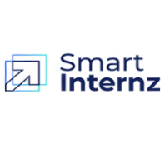
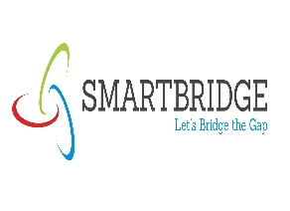

PROJECT DOCUMENTATION — EDUGENIE AI

1. PROJECT TITLE
EDUGENIE – AI POWERED LEARNING ASSISTANT

DESCRIPTION:
EduGenie is an AI-powered learning assistant designed to help students understand and revise academic topics easily. The application uses Google Gemini to provide intelligent responses based on the user's input.

2. PROJECT OBJECTIVE
The main objective of EduGenie is to provide students with a simple and interactive platform for learning assistance. It helps students ask questions, summarize study materials, generate quizzes, and create structured study notes using Artificial Intelligence.

3. TECHNOLOGIES USED
- Frontend: HTML, CSS, JavaScript
- Backend: Python, Flask
- AI: Google Gemini API
- Database: SQLite
- Development Tool: Visual Studio Code
- Environment: Python Virtual Environment

4. PROJECT SETUP
The project was created in Visual Studio Code with a separate project folder named EduGenie AI. The required Python environment and project dependencies were configured before running the application.

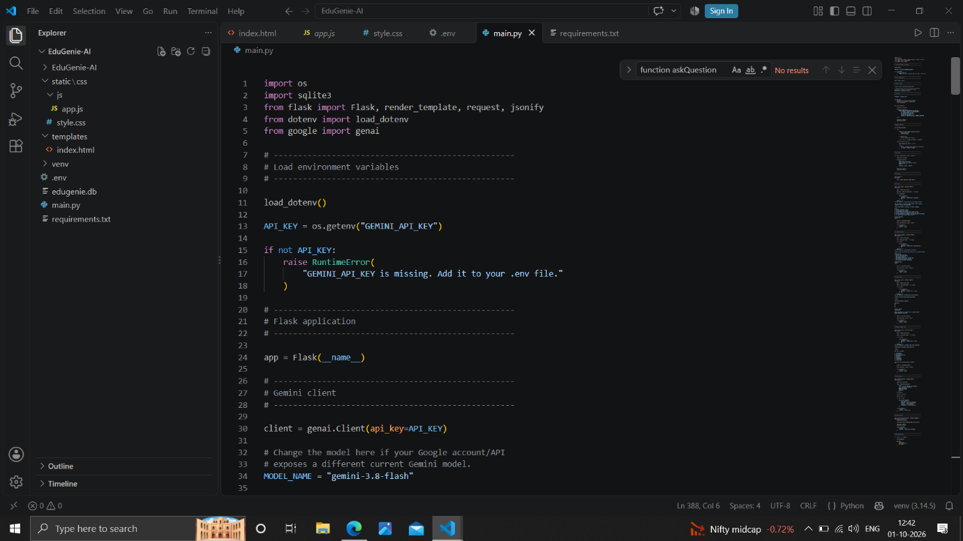

5. INTRODUCTION
EduGenie AI is an AI-powered educational web application designed to assist college students in their learning activities. The system provides students with quick and structured academic support using Generative Artificial Intelligence.
The application allows users to ask academic questions, summarize study materials, generate quizzes, and create structured study notes. The backend is developed using Python and Flask, while Google Gemini AI is used to generate intelligent responses. SQLite is used to store user interactions and generated responses.

6. PROJECT OVERVIEW
EduGenie AI acts as a virtual learning assistant for students. The application receives user input through the web interface and processes it through the Flask backend.
Based on the selected feature, the backend prepares an appropriate prompt and sends it to the Google Gemini AI service. The generated response is then returned to the user and stored in the database.
The main features of the application are:
- AI Chat Assistant
- Study Material Summary
- Quiz Generation
- Study Notes Generation
- Chat History Storage

7. PROBLEM STATEMENT
Students often need quick explanations, summaries, revision notes, and practice questions while preparing for their studies. Finding and organizing suitable learning content from different sources can take considerable time.
EduGenie AI is developed to provide these learning requirements through a single application. By using Generative AI, the system can provide explanations, summaries, quizzes, and notes based on the user's input.

8. OBJECTIVES
The main objectives of EduGenie AI are:
- To provide an AI-based learning assistant for students.
- To answer academic questions in a simple and understandable manner.
- To summarize lengthy study materials.
- To generate practice questions automatically.
- To create structured study notes.
- To store user interactions for future reference.
- To provide multiple educational features through a single web application.

9. SCOPE OF THE PROJECT
EduGenie AI focuses on providing AI-based academic assistance for college students.
The system can be used for:
- Understanding academic concepts.
- Quick revision of study materials.
- Preparing practice questions.
- Creating structured notes.
- Getting explanations for academic doubts.
The application can be further extended with features such as user authentication, progress tracking, document upload, personalized learning, and mobile application support.
10. TECHNOLOGIES USED
Python
Python is used as the primary programming language for implementing the backend functionality.
Flask
Flask is used as the web framework for handling application routes, requests, and responses.
Google Gemini AI
Google Gemini is integrated into the application to generate AI-based educational responses.
SQLite
SQLite is used as the database for storing chat history and generated responses.
HTML, CSS and JavaScript
These technologies are used to create and manage the frontend user interface.
Python-dotenv
The dotenv package is used to load configuration values such as the Gemini API key from the environment.

11. SYSTEM REQUIREMENTS
Hardware Requirements
- Computer or laptop
- Minimum 4 GB RAM
- Internet connection
- Keyboard and mouse
Software Requirements
- Python
- Visual Studio Code
- Web browser
- Flask
- SQLite
- Google Gemini API

12. PROJECT STRUCTURE
The project contains separate components for the backend, frontend, database, and configuration.
The major files and folders are:
- main.py – Main backend application.
- templates/index.html – Main HTML page.
- static/css/style.css – Application styling.
- static/js/app.js – Frontend functionality.
- .env – Environment configuration.
- edugenie.db – SQLite database.
- requirements.txt – Required Python packages.

13. SYSTEM ARCHITECTURE
EduGenie follows a simple web-based architecture.
The user interacts with the frontend application. The frontend sends the request to the Flask backend. The backend validates the input and prepares a suitable prompt according to the selected feature.
The prompt is then sent to Google Gemini AI. After receiving the generated response, the backend stores the interaction in the SQLite database and sends the result back to the frontend.
System Flow
User → Frontend → Flask Backend → Gemini AI → SQLite Database → Frontend → User

14. FUNCTIONAL MODULES
EduGenie AI consists of four major AI-based modules:
- AI Chat Module
- Study Material Summary Module
- Quiz Generation Module
- Study Notes Generation Module
In addition, the application contains a database module for storing user interactions.

15. AI CHAT MODULE
The AI Chat module allows students to ask questions related to their academic subjects.
When the user submits a question, the backend receives the request through the chat API. The question is validated and converted into an educational prompt.
The prompt instructs the AI to provide clear explanations, use simple language, give examples when required, and break difficult concepts into smaller parts.
The generated response is returned to the user and stored in the chat history.

16. STUDY MATERIAL SUMMARY MODULE
The Summary module is used to convert lengthy study material into concise and useful learning content.
The user provides the study material through the application. The backend validates the input and creates a summary-specific prompt for Gemini AI.
The generated summary focuses on important points and uses simple language. Important technical terms are retained so that the summary remains useful for academic revision.

17. QUIZ GENERATION MODULE
The Quiz Generation module helps students practice a particular topic.
The user provides a topic, and the backend sends a structured prompt to Gemini AI. The system requests five multiple-choice questions with four options for each question.
The generated content also includes the correct answer and an explanation. This allows students to use the generated quiz for self-assessment and examination preparation.

18. STUDY NOTES GENERATION MODULE
The Study Notes module generates structured academic notes based on a topic provided by the user.
The system organizes the generated content into different sections such as:
- Definition
- Introduction
- Important Concepts
- Key Points
- Example
- Advantages
- Limitations
- Conclusion
This structured format makes the generated content suitable for quick revision and academic preparation.
19. DATABASE MANAGEMENT
EduGenie uses SQLite as its database system.
The database is used to maintain the history of interactions between the user and the AI system. The application stores information such as the user's message, AI-generated response, feature used, and creation time.
The main database table is chat_history.
Database Information
FIELD | DESCRIPTION
ID | Unique record identifier
User Message | Input provided by the user
AI Response | Response generated by Gemini
Feature | Featured used by the user
Create At | Date and time of the interaction

20. GEMINI AI INTEGRATION
Google Gemini AI is the main Artificial Intelligence component of EduGenie.
The application initializes the Gemini client using an API key obtained from the environment configuration. The backend creates different prompts depending on the feature selected by the user.
The AI response is then processed by the backend and returned to the frontend.
The common AI processing flow is:
User Input → Prompt → Gemini AI → Generated Response → Database → User

21. API ENDPOINTS
The Flask backend provides different endpoints for the major features.
ENDPOINT | METHOD | PURPOSE
/ | GET | Loads the main application page
/chat | POST | Processes  academic questions
/summary | POST | Generates study material summaries
/quiz | POST | Generates quizzes
/notes | POST | Generates study notes

These endpoints allow the frontend to communicate with the backend and receive AI-generated results.

22. BACKEND PROCESSING
The backend is mainly implemented in the main.py file.
The backend performs the following tasks:
- Starts the Flask application.
- Loads environment variables.
- Initializes the Gemini AI client.
- Connects to the SQLite database.
- Validates user input.
- Creates feature-specific AI prompts.
- Sends requests to Gemini.
- Stores generated responses.
- Returns results to the frontend.

23. INPUT VALIDATION AND ERROR HANDLING
The application performs basic validation before processing user requests.
For example, the system checks whether the user has entered:
- A question for the Chat feature.
- Study material for the Summary feature.
- A topic for Quiz generation.
- A topic for Study Notes generation.
If the required input is missing, the backend returns an appropriate error response.
The Gemini request is also handled using exception handling so that unexpected AI service errors can be managed without stopping the entire application.

24. APPLICATION WORKFLOW
The overall working process of EduGenie is:
- The user opens the EduGenie application.
- The user selects a required feature.
- The user enters the required information.
- The frontend sends the request to Flask.
- Flask validates the input.
- The backend creates the appropriate AI prompt.
- The prompt is sent to Gemini AI.
- Gemini generates the response.
- The response is stored in SQLite.
- The generated result is returned to the frontend.
- The user views the result.

25. FRONTEND
The frontend of EduGenie is organized into HTML, CSS, and JavaScript files.
HTML
The HTML file provides the basic structure of the application interface.
CSS
The CSS file controls the appearance, layout, and styling of the application.
JavaScript
The JavaScript file handles user interactions and communication between the frontend and Flask backend.

26. APPLICATION EXECUTION
The Flask application is executed through the Python backend.
The application can be started from the project directory, after which Flask runs the application on the local development server.
The running application can be accessed through the local Flask address shown in the terminal.

27. TESTING
The major functionalities of EduGenie can be tested using different input conditions.
TEST CASE | EXPECT
Valid academic question | AI-generated explanation
Empty question | Validation message
Valid study material | Generated summary
Valid quiz topic | Five MCQs generated
Valid notes topic | Structured notes generated
Empty topic | Validation message
Gemini service error | Error handled by backend

Testing helps verify that the main features respond correctly to valid and invalid inputs.

28. ADVANTAGES
- Provides quick academic assistance.
- Supports multiple learning activities.
- Reduces time required for preparing summaries and notes.
- Automatically generates practice questions.
- Provides simple and structured explanations.
- Stores interaction history.
- Combines multiple AI learning features in one application.
- Easy to extend with additional educational features.

29. LIMITATIONS
- The application depends on the availability of the Gemini AI service.
- An internet connection is required for AI-based responses.
- AI-generated content may require verification before academic use.
- The current database implementation is suitable for a basic application and may require scalability improvements for large numbers of users.
- The application currently focuses mainly on text-based learning assistance.

30. FUTURE ENHANCEMENTS
The following features can be added in future versions:
- Student login and registration.
- Personalized student profiles.
- Learning progress tracking.
- Quiz score management.
- PDF and document upload.
- AI-generated flashcards.
- Voice-based learning assistance.
- Multilingual support.
- Personalized learning recommendations.
- Mobile application.
- Cloud database integration.
- Advanced chat history and analytics.

31. CHAT HISTORY MANAGEMENT
The Chat History Management module allows the system to retrieve and display the user's previous interactions with EduGenie AI. The stored conversations are obtained from the chat_history database table through a dedicated history endpoint.
The system retrieves the recent chat records along with the user's question, AI-generated response, feature used, and the corresponding date and time. The records are arranged in descending order so that the latest interactions are available first. A limit of 50 records is applied to keep the response manageable and efficien
The retrieved database records are then converted into a structured history format. Each record contains details such as the question, answer, feature name, and creation time. This structured data is returned to the frontend in JSON format, allowing the user interface to present the previous learning interactions clearly.

32. HISTORY API RESPONSE
The History API provides a successful response containing the retrieved conversation data. The response includes a success status and a history collection containing the stored interactions. This approach creates a clear communication mechanism between the Flask backend and the frontend.
The Chat History feature improves the overall usability of EduGenie AI by allowing users to revisit their previous questions and AI-generated answers. It also provides a useful record of the different educational features used during the learning process.

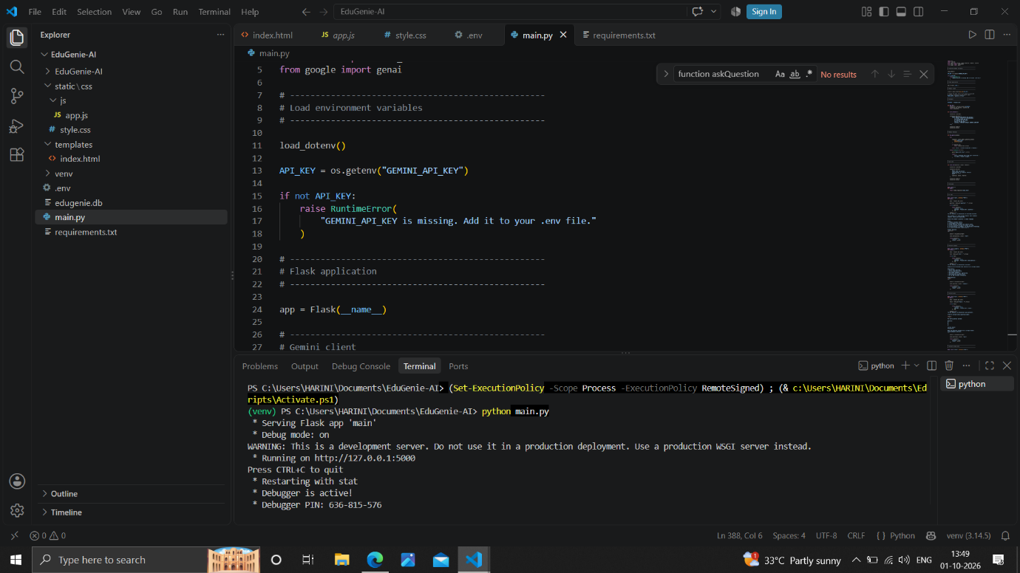

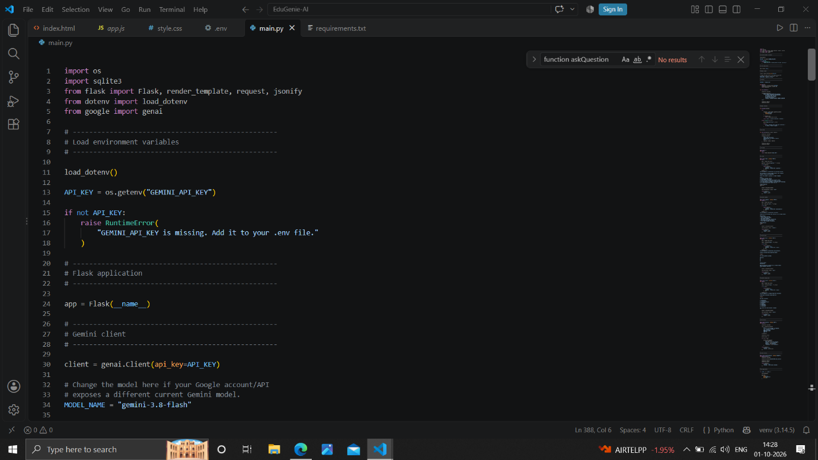

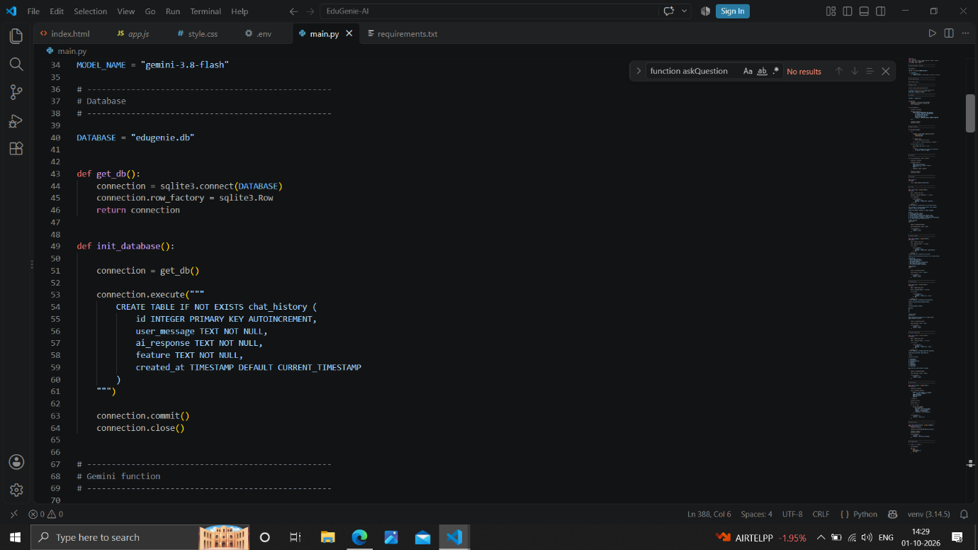

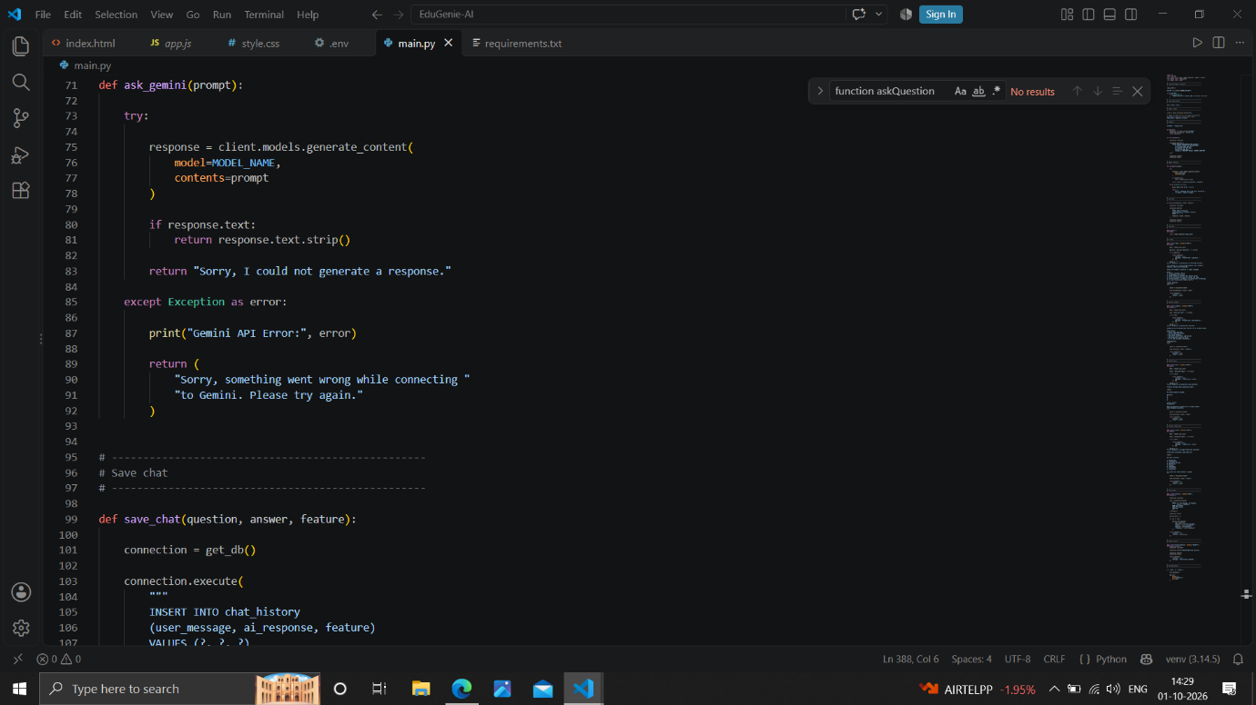

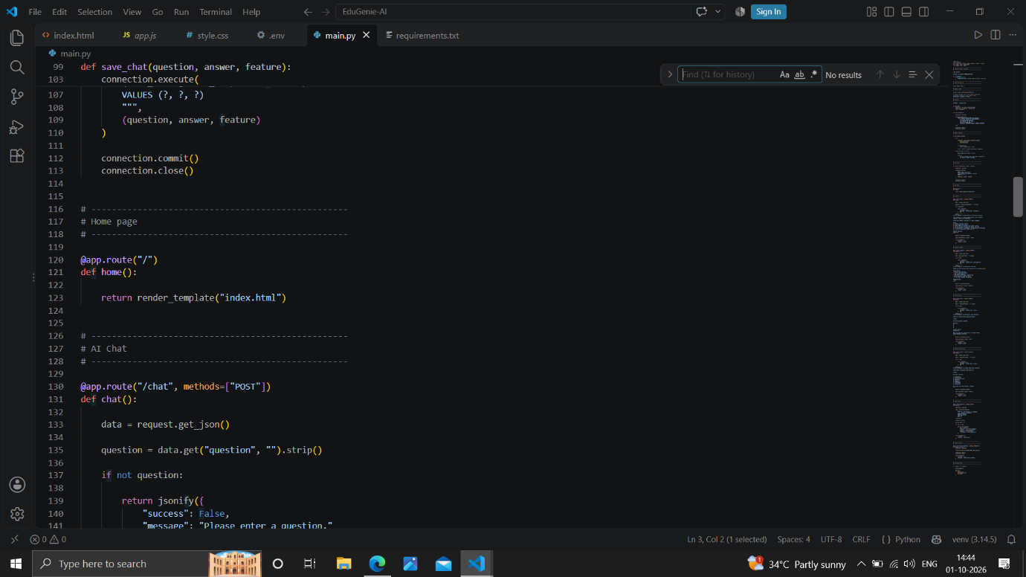

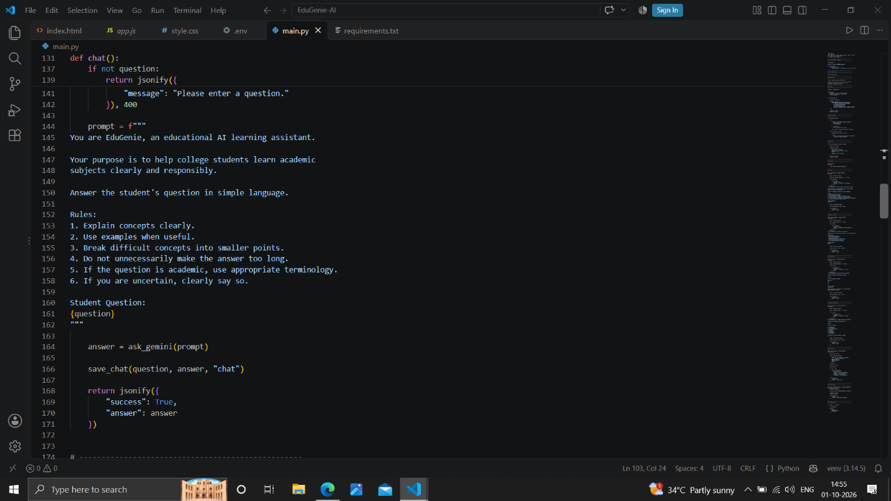

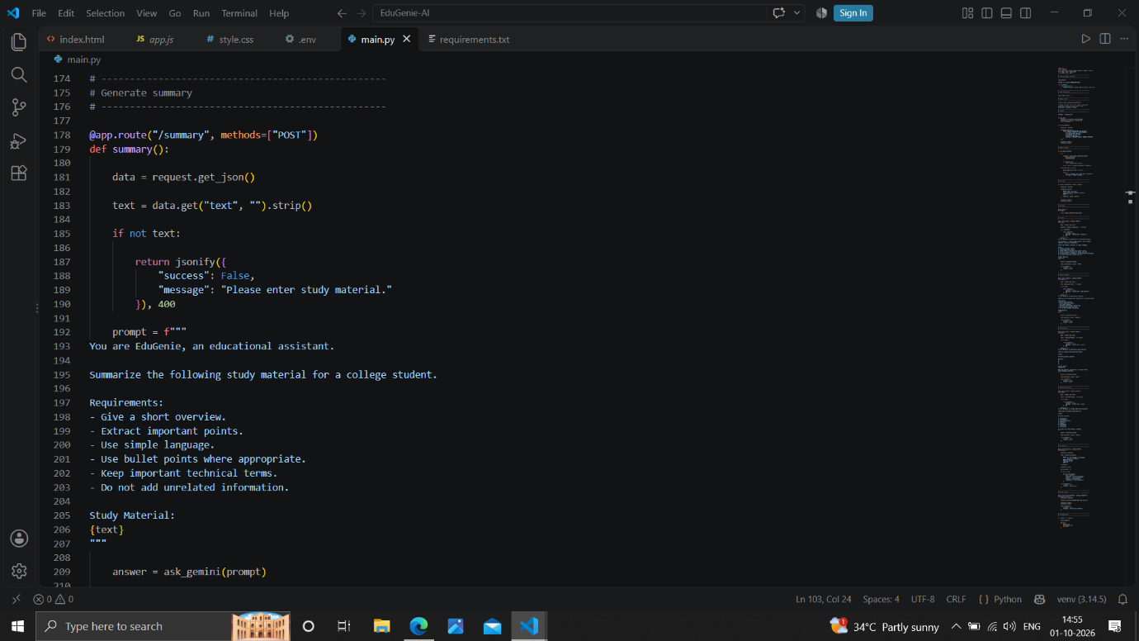

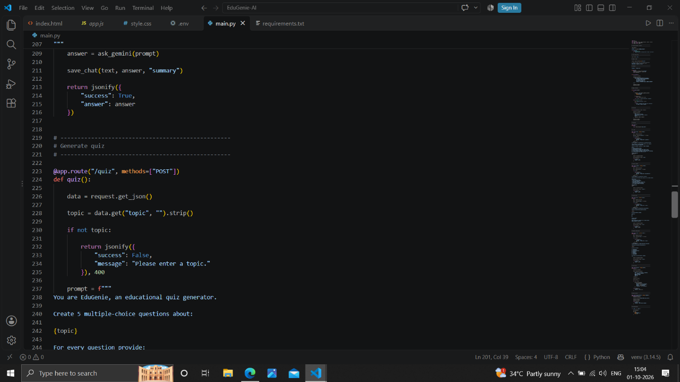

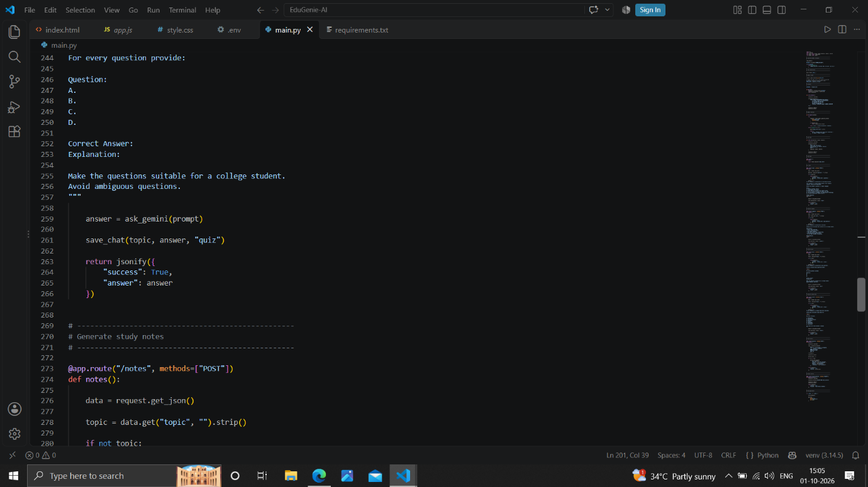

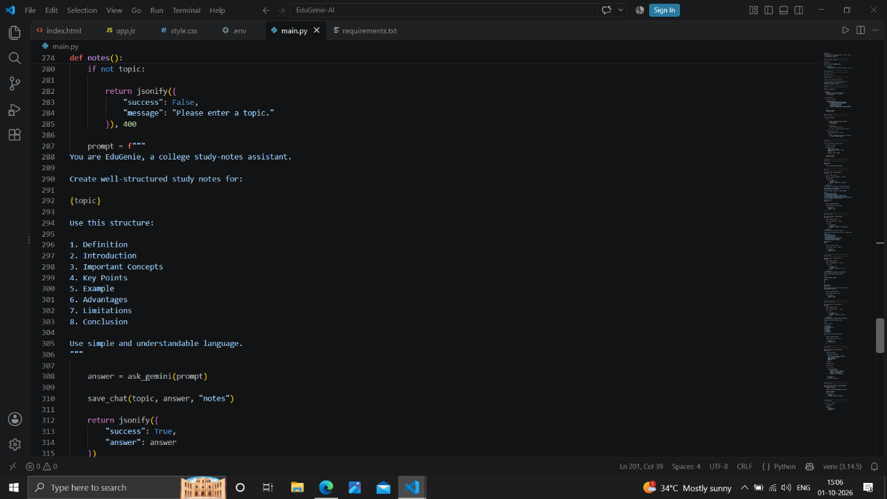

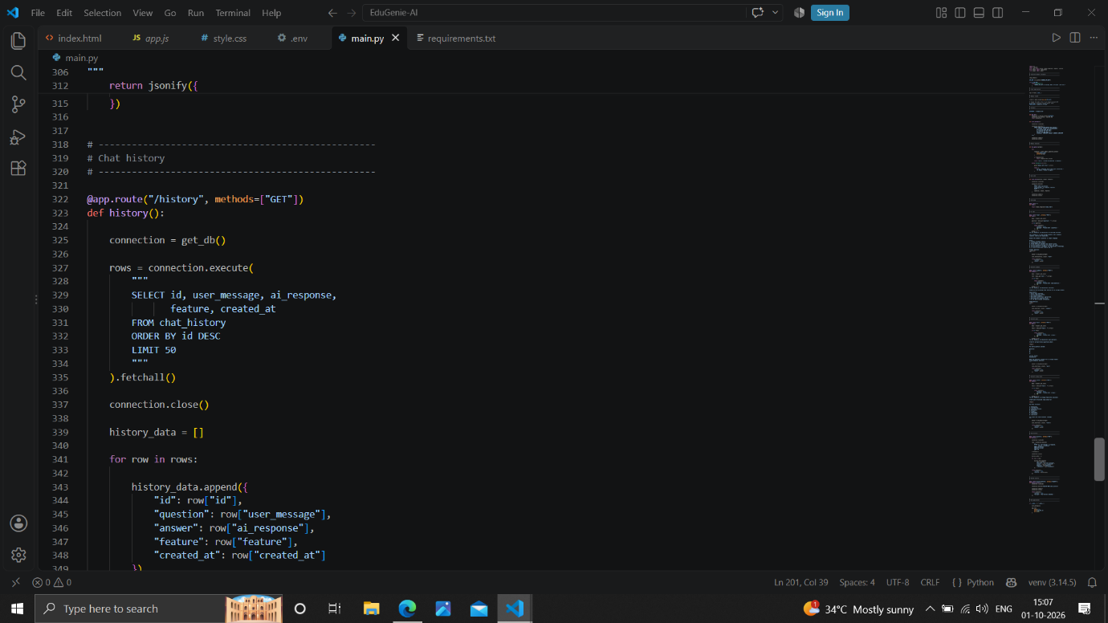

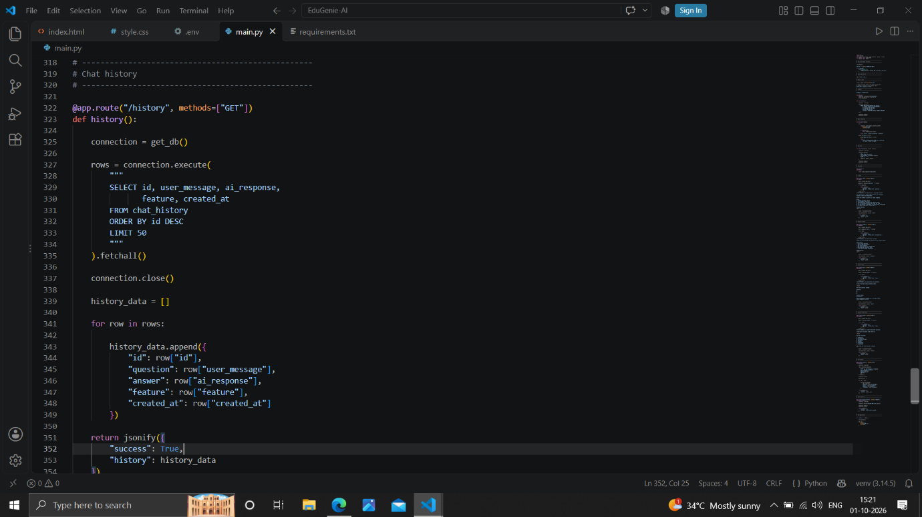

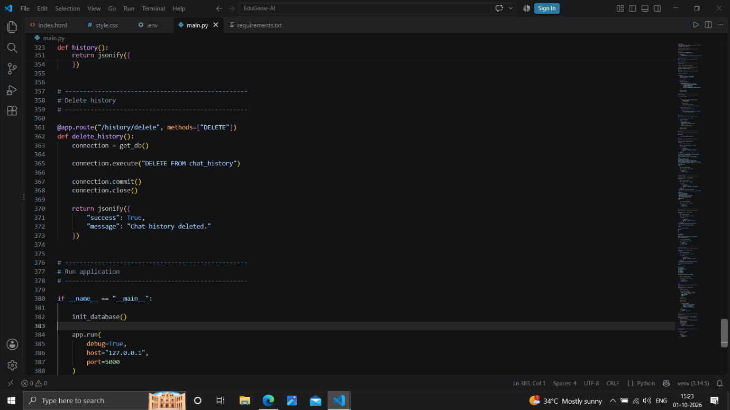

33. CONCLUSION
EduGenie AI is an AI-powered educational learning assistant designed to support students in understanding and organizing their study materials more effectively. The system combines a Flask-based backend, a simple web interface, SQLite database management, and Gemini AI integration to provide multiple learning-oriented features in a single application.
The application provides useful functionalities such as AI-based question answering, study material summarization, quiz generation, and structured note creation. The integration of the database also allows user interactions and AI responses to be stored and retrieved through the Chat History module. This helps maintain a record of previous learning activities and improves the overall usability of the system.
The project demonstrates how Artificial Intelligence can be integrated with a web application to provide personalized and interactive educational support. Through its modular design, EduGenie AI provides a foundation that can be further extended with additional educational features, improved user interfaces, authentication, and more advanced learning capabilities.
Overall, the project successfully demonstrates the development of a practical AI-based educational assistant that can assist learners with different stages of their study process, from understanding concepts to creating summaries, notes, quizzes, and reviewing previous interactions.

